**BBM102 – Introduction to Computer Programming II – Spring 2020**

**Final Exam – The First Session**

**July 1, 2020, 10:05-10:25**

**First name / Last name:**

**Student ID:**

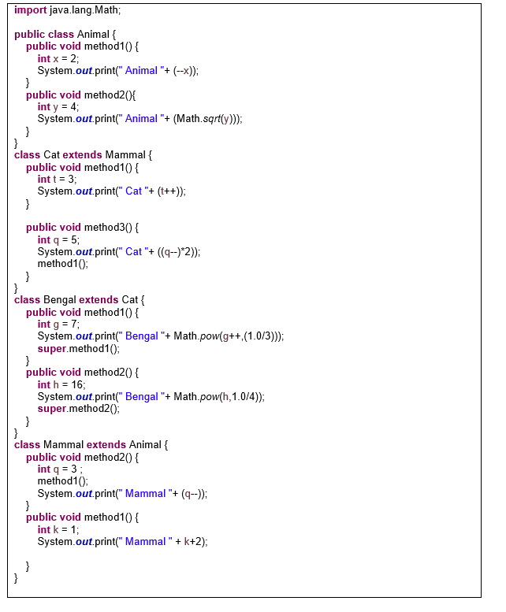

**1.** According to the Java code given above, considering the variable definitions given below, write down the outputs of each of the Java method calls to the nearby blank areas. If there is an error/exception, please write one-sentence explanation. ***(23 points)***

Object o = **new** Animal();

Animal a = **new** Mammal();

Mammal m = **new** Cat();

Cat d = **new** Bengal();

m.method1(); ___________________________________

m.method2(); ___________________________________

m.method3(); ___________________________________

d.method1(); ___________________________________

d.method2(); ___________________________________

d.method3(); ___________________________________

a.method1(); ___________________________________

a.method2(); ___________________________________

a.method3(); ___________________________________

((Animal) o).method1(); ___________________________________

((Mammal) o).method2(); ___________________________________